_____________________________________________________________________________________

To

Hiring Manager,   
Yahoo,  
USA.

Dear Hiring Manager,

I am writing to express my interest in an Internship for summer 2016 with Yahoo .Currently, I am pursuing a Master’s in Computer Science from Texas A&M University, College station. I learned about this Internship opportunity with Yahoo from Texas A&M University, Career Center.

Having comprehensive computer science background, I also have sound prior work experience of 2 years in Java, Web services, Software Performance Analysis. I have enrolled in analysis of algorithms, software engineering courses which will give me deep insights of these subjects. I feel your firm places prominence in similar areas and having the privilege of serving as an intern with you will give me that further exposure I need to advance my career.

Upon graduation, I hope to work towards design and development of software which will require my technical knowledge and problem solving skills. With the right opportunities and experience with cutting edge projects and design, I believe I can achieve this goal with your firm’s help.

Internship opportunity with Yahoo will provide me hands on experience on real world complex projects and products like Mail, Search, Sports and News Blogging etc. I am particularly interested to work towards full stack development where I get an opportunity to deal with challenging problems. I see that you have an open Intern position in this area with challenging work that can give me well career start and knowledge. I am actively seeking the kind of challenge and knowledge offered from technically innovative firm in this global market.

I am eager to have a chance to discuss about this position with you in an interview. Please contact me on (979)-985-7082. Thank you for your attention I look forward to hear from you.

Sincerely,

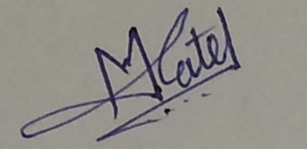

Minav Suresh Patel